

National College of Ireland

Honours in Computing

Software Development

2024/2025

Karl Miller

X21522489

X21522489@student.ncirl.ie

Tales of Atheria

Technical Report

Link to Github: <https://github.com/HyperPixel-212/Tales-of-Atheria>

Contents

Executive Summary 2

1.0 Introduction 2

1.1. Background 2

1.2. Aims 2

1.3. Technology 2

1.4. Structure 2

2.0 System 2

2.1. Requirements 2

2.1.1. Functional Requirements 2

2.1.1.1. Use Case Diagram 2

2.1.1.2. Requirement 1 <Name of requirement in a few words> 2

2.1.1.3. Description & Priority 2

2.1.1.4. Use Case 3

2.1.2. Data Requirements 4

2.1.3. User Requirements 4

2.1.4. Environmental Requirements 4

2.1.5. Usability Requirements 4

2.2. Design & Architecture 4

2.3. Implementation 4

2.4. Graphical User Interface (GUI) 4

2.5. Testing 4

2.6. Evaluation 4

3.0 Conclusions 4

4.0 Further Development or Research 4

5.0 References 5

6.0 Appendices 5

6.1. Project Proposal 5

6.1. Ethics Approval Application (only if required) 5

6.2. Reflective Journals 5

6.3. Invention Disclosure Form (Remove if not completed) 5

6.4. Other materials used 10

# Executive Summary

Tales of Atheria is a side story in the world known as Atheria, these tales focus on Important figures within the world. This particular story is about a famous Blacksmith called Selum P.Unker in the time before his breakthrough within the Metal work industry. However, in this current time the world is in an uncertain spot. The void is ravaging the many mines within Atheria causing problems in the city of Quarrine where Mining is their main trade and while Selum isn’t an experienced fighter he wants to save his town from the decline it faces and restore it to its previous glory! The goal of the game is to venture down into the dangerous depths of the Quarrine Mines and gather all the resources you can while Fighting whatever monsters may stop you, If you successfully manage to retrieve resources from the mines you might be able to help your allies in town or create some new gear!

# Introduction

## Background

I’ve taken up this project as since i was a child I've had a big interest in video games and later a large interest in RPG and Roguelikes as they have lots or replayability and immersive stories that I could play repeatedly. I made an immersive story in my head over the years and while I'm not focusing on that with this project because the scope is too large so I used one of my smaller plots in the same world, The countless hours of thinking about this story will help me develop it properly as I know how it will look and play. I feel as though working on something that I’m truly interested in will motivate me to put my all into this project and make something I can be proud of.

## Aims

I intend to create a Videogame with rougelike elements such as randomised floors and item drops from enemies. A Rougelite is a type of Role-Playing Game (RPG) that is described as a Dungeon crawl through procedurally generated levels with Grid based movement and most Rougelikes have permadeath of the player character, however most modern Rougelikes have other styles meshed into them too. For example, Slay the Spire is a rougelike with card game mechanics or The Binding of Isaac being a Rougelike and a Twin-stick shooter. My game Tales of Atheria is a Rougelike and a Village management game where you can upgrade the buildings in the town to unlock better items in the shops. I also want to leave a lot of the gameplay up to player discovery and let them figure things out since a lot of games hold your hand and I feel it's more rewarding to play and learn.

## Technology

RPGMaker MV: It is my main software for developing the game when it comes to programming the game and all the mechanics and gameplay. RPGMaker is mainly for creating RPG but many you can create just about anything with it if you know how to use it properly. Another thing RPGmaker can do is allow players to use their own sprites for creating their own games but it also has templates that come with a copy of the software. Something that makes it a software I love is that its super easy to understand how to create things within it but it has enough power to create incredibly complex events and mechanics.

Aesprite: Aesprite is a Pixel art software that I am using for creating and modifying sprites for tiles such as Weapon or Ore sprites, Aesprite is also very easy to use but its one of the best pixel art softwares out there as it has many different tools that can allow users to create beautiful pieces of art or just use it as a simple software, It also is extremely accessible to users as its UI is easy to take in.

Github: Github is a developer platform that allows people to create repositories for file storage and development as people can push and pull files easily acting as a bridge of sorts to easily grab files and work on projects. It's also a great safety net in case file corruption or anything of that sort

## Structure

This document will contain all the necessary Functional requirements that are associated with the design of my game, these requirements will outline key components that will have to be in the game and working without issues for the game to work as intended. Further down they are showcased with Use case diagrams which will outline how a User/Actor interacts with the system.

# System

## Requirements

Ones labelled as Functional requirements are required and are needed to be shown off in the final showcase of the game, A second section will be added for the Non-Functional requirements. The Non-Functional requirements are features that I would like to have in the game, but they aren’t needed for the game to function.

## Functional Requirements

The Requirements listed here will be ordered from Highest to Lowest priority.

**Functional Requirements:**

1. Walking around:
   1. Highest Priority
      1. Allows the user to move around within the game.
      2. This is the Highest priority as if the user cannot move around then the user cannot play the game and the game cannot continue
2. Opening the Inventory/Menu:
   1. High Priority
      1. Allows the player to pause the game, check their resources they have collected and save their progress
      2. This is right below the priority of walking around as if the player cannot use this feature, then they cannot do a lot of important functions in the game.
3. Saving/Loading progress:
   1. High Priority
      1. Saving/Loading the game is an extremely important feature that needs to exist and function properly.
      2. This is one of the higher priorities as if the player cannot save the game, then they would repeatedly lose their progress.
4. Level progression:
   1. Medium Priority
      1. The user moves down a level in the mines by interacting with the ladder
      2. If this does not function, then the main gameplay cannot be accessed by the player
5. Exiting the Mines:
   1. Medium Priority
      1. The user Interacts with the ladder to exit the mines and return to the surface
      2. If this doesn’t function, then the user wouldn’t be able to return to the town without dying and respawning
6. Interaction:
   1. Medium Priority
      1. The user uses the “Enter” key to interact with near every object in the game, NPCs, Rocks, Chests, Moving areas.
      2. If this is not functional then the player cannot do most functions the game requires
7. Battles:
   1. Medium Priority
      1. Battles will happen randomly while the User is within the cave as they walk around.
      2. While it's not as important as the above, If battles don't work then the player will walk around open caves without a challenge.

**Non-functional requirements:**

1. Fleeing battles:
   1. Medium Priority
      1. While this feature is not required it would be better if It was to be added as it gives the player freedom within battles if they want to escape if they are low on HP or if they just don’t want to fight
      2. The player would progressively have a higher chance at escape the more attempts they do in battle, and it resets when there is a successful escape attempt
2. Items in battle:
   1. Medium Priority
      1. This would also give players another chunk of freedom in battle as they can use items in various ways to assist them within battle
      2. If this was to not exist it could make fights difficult as they would not be able to heal etc, which would be a huge problem in boss fights.
3. Opening Chests:
   1. Medium Priority
      1. This one is needed for the gameplay experience but not needed for the game to function as a whole, this will be how players find items like Potions etc.
      2. Having the player find items allows for more freedom in playstyles and show a little more professionalism with development

## Requirement 1 Walking

Use case for walking via User interaction

## Priority

The user must press the arrow keys to move around within the overworld, While the user is within the overworld they should be able to walk around with their own free will. If the user cannot do that, they would be unable to play the game and as such this would have the Highest priority of all functions within the game.

## Use Case

**Name**

Walking use case

**Number**

Use case 001

**Scope**

The scope of this use case is to showcase the user Walking around

**Description**

This use case describes the user hitting one of the arrow keys and in response the character in game should move corresponding to the arrow key pressed by the user

**Use Case Diagram**

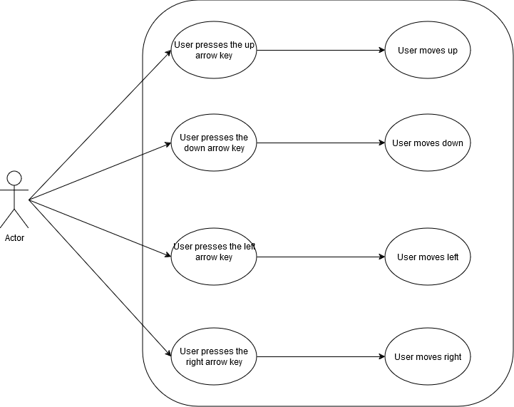

**Flow Description**

**Precondition**

The system is in a wait state on the “overworld”

**Activation**

This use case starts when the user presses an arrow key

**Main flow**

1. The user presses any arrow key (Up, Down, Left, Right)

2. The system responds to the button press and moves the character in the corresponding direction.

**Exceptional flow**

1. The system crashes.
2. The system autosaves
3. The game reopens

**Termination**

The system recognises the game has been closed

**Post condition**

The system goes into a wait state awaiting the player to press another arrow key

## Requirement 2 Saving/Loading

Use case for Saving/Loading via User interaction

## Priority

Saving/Loading the game is an extremely important feature that allows the user to continue playing from a save point they have created and as such it's one of the Highest priority features that needs to be functional

**Name**

Saving/Loading use case

**Number**

Use case 002

**Scope**

The scope of this use case is to show off saving and loading game data

**Description**

This use case describes the process of saving in game loading save data to continue playing

**Use Case Diagram**

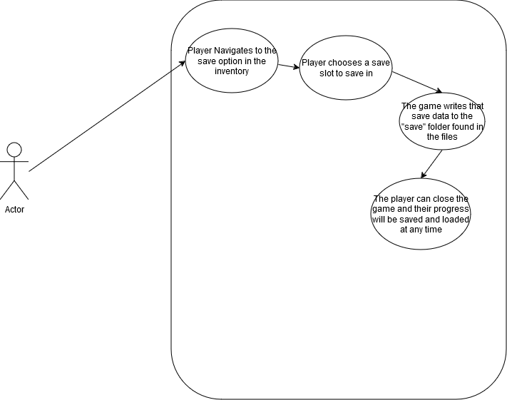

**Flow Description**

**Precondition**

The user is in the save category within the inventory and the system allows the user to save (Area dependant)

**Activation**

This use case starts when the user chooses the slot to save their progress

**Main flow**

1. The user saves their game with the save option in the inventory
2. The user confirms the slot they want to save in
3. The system writes the save data to the save folder in the game files
4. The player can close the save section in the inventory and continue playing

**Alternate flow**

1. The user loads their save data in the main menu by hitting the “Continue” option in the main menu
2. The system finds the selected save file from the “saves” folder
3. The system loads that file and opens the game at the point the player saved at previously.

**Exceptional flow**

1. The system crashes.
2. The system autosaves.
3. The game reopens.

**Termination**

The system has saved the data successfully/ The system has loaded the data correctly.

**Post condition**

The system goes into a wait state until the next time the user saves/loads data.

## Requirement 3 Opening/Closing the Inventory

Use case for opening the Inventory via User interaction

## Priority

The user opens the Inventory with the ESC key and the System displays the Inventory as a result of the user pressing ESC and vice versa if the inventory is already open. This is one of the Highest priority features as if this doesn't work the player can access anything within the inventory, Including saving the game

Name

Inventory use case

**Number**

Use case 003

**Scope**

The scope of this use case is to give a rough explanation of the inventory and how it works

**Description**

This use case describes the way the player can interact with the Inventory system

**Use Case Diagram**

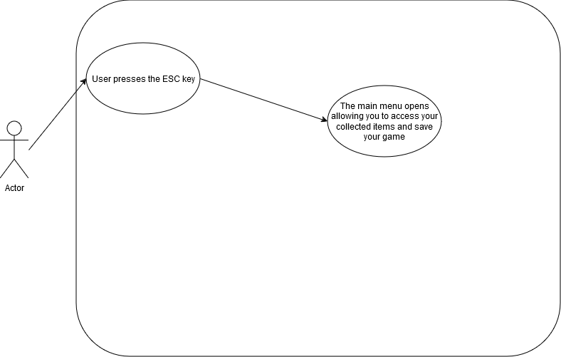

**Flow Description**

**Precondition**

The system is currently outside of battle and on the overworld without the menu already being open

**Activation**

This use case starts when an Actor presses the ESC key, pressing this will make the system open the inventory

**Main flow**

1. The user presses the ESC key
2. The system recognises the user pressed the ESC key
3. The system opens the Inventory
4. The player may access the various options in the inventory menu

**Alternate flow**

1. The player presses the ESC key while the Inventory is open already
2. The system recognises the user pressed the ESC key
3. The system closes the Inventory

**Exceptional flow**

1. The system crashes.
2. The system autosaves
3. The game reopens

**Termination**

The system either recognises the game was terminated or it a battle started

**Post condition**

The system awaits the next input of the ESC key

## Requirement 4 Battle: Attacking

This shows off the attack command within battle for the player

## Priority

If battling is to be in the game, then all commands must be functional as intended this will include Attacking, including all the commands and this one it will all be classed as medium priority as the battles are a core gameplay mechanic that need to work

**Name**

Player attack use case

**Number**

Use case 004

**Scope**

The scope of this use case is to explain the processes of attacking an enemy.

**Description**

This use case describes the processes of attacking

**Use Case Diagram**

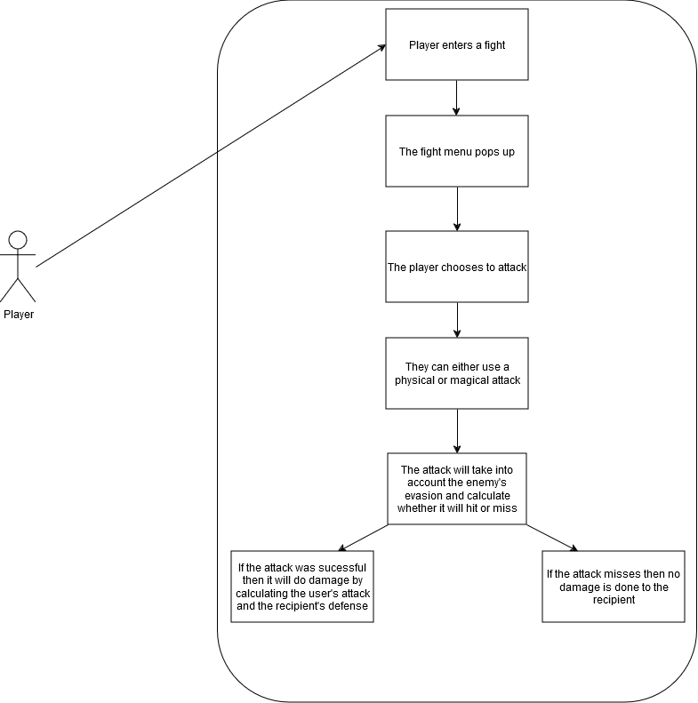

**Flow Description**

**Precondition**

The player must have entered a battle with an enemy

**Activation**

The player must currently be in a battle with an enemy.

**Main flow**

1. The system identifies that the battle has started
2. The system pulls up the battle menu for the User
3. The Player gets to pick the options of Attack, Magic, Item and Flee
4. The Player chooses Attack which then the Player can choose their target for the attack
5. The attack either hits or misses.

5i. If the attack hits it deals damage to the enemy

5ii. If the attack misses nothing happens

6. The Player’s turn ends and It becomes the enemy’s turn

7. It becomes the enemy’s turn (Look at Enemy Attack use case)

**Exceptional flow**

1. The system crashes.
2. The game reopens at home page.
3. The game autosaves.

**Termination**

The battle ending via the player defeating the enemy or the player dying in battle.

**Post condition**

The system goes into a wait state until the next battle begins.

**List further functional requirements here, using the same structure as for Requirement1.**

## Requirement 5 Death process

This shows off what happens when the player dies

## Priority

The player dying is an important feature that must be implemented alongside battling, If death isn't added it give the player no sense of worry when they partake in battles as they wouldn't be punished for failure, Death would have the same priority as the battle mechanics as its in integral part of the game

**Name**

Player death use case

**Number**

Use case 005

**Scope**

The scope of this use case is to showcase the process of dying in the game.

**Description**

This use case describes the process of what happens when you die

**Use Case Diagram**

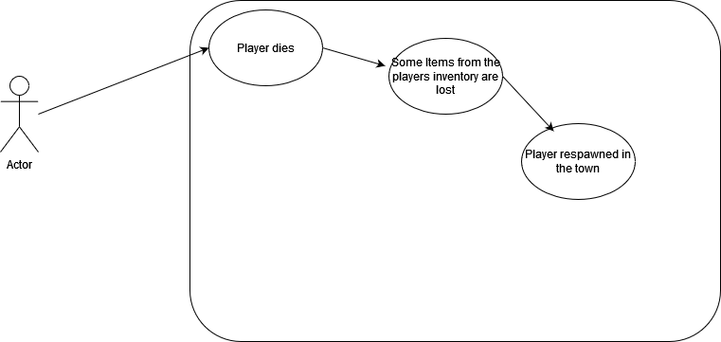

**Flow Description**

**Precondition**

The player must have entered a battle with an enemy

**Activation**

The player must have lost a battle with an enemy

**Main flow**

1. The player’s HP drops to 0
2. The System displays a message informing the Player they lose the fight
3. The system chooses at random 10% of their collected items to be removed from inventory.
4. The system respawns the player at their base
5. The System displays a message informing the Player of item lost from inventory

**Alternate flow**

1. The player tries to flee battle
2. The player fails to escape
3. The enemy hits the player
4. The player’s HP is dropped to 0
5. The Player dies
6. The system respawns the player at their base
7. The System displays a message informing the Player of item lost from inventory

**Exceptional flow**

1. The system crashes.
2. The game reopens at home page.
3. The game autosaves.

**Termination**

The system respawns the player at their base and allows them to continue playing.

**Post condition**

The system goes into a wait state until the player falls in battle again or dies on some other way.

## Requirement 6 Battle: Items

This shows off the Items command within battle for the player

## Priority

If battling is to be in the game, then all commands must be functional as intended this will include using Items, including all the commands and this one it will all be classed as medium priority as the battles are a core gameplay mechanic that need to work

**Name**

Player Item use case

**Number**

Use case 006

**Scope**

The scope of this use case is to show the use of items in battle

**Description**

This use case describes the process of using an item in battle

**Use Case Diagram**

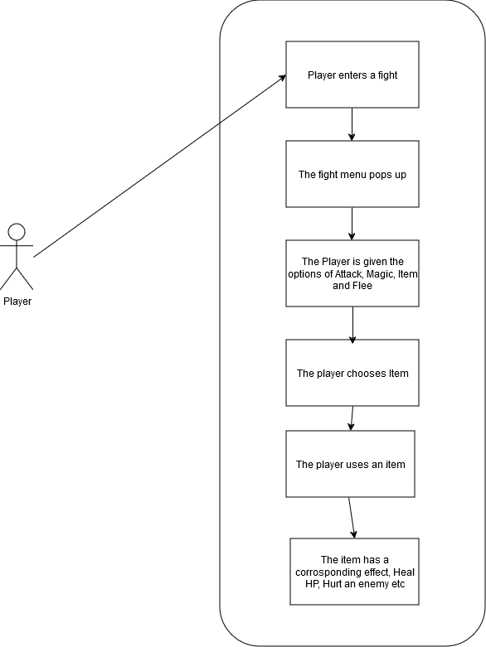

**Flow Description**

**Precondition**

The player must have entered a battle with an enemy

**Activation**

The player must currently be in a battle with an enemy.

**Main flow**

1. The player opens item menu
2. The Player chooses item from menu
3. The player uses an item
4. The item has a specific effect (Heal user, Harm enemy etc)
5. The system subtracts 1 instance of that specific item from the player's inventory
6. The Player’s turn ends

**Exceptional flow**

1. The system crashes.
2. The game reopens at home page.
3. The game autosaves.

**Termination**

The system ends the Player’s turn and changes it to the Enemy’s turn

**Post condition**

The system goes into a wait state until the player gets into another battle

## Requirement 7 Battle: Fleeing

This shows off the attack command within battle for the player

## Priority

If battling is to be in the game, then all commands must be functional as intended this will include Fleeing, including all the commands and this one it will all be classed as medium priority as the battles are a core gameplay mechanic that need to work

**Name**

Player flees use case

**Number**

Use case 007

**Scope**

The scope of this use case is to show the flee mechanic in battle

**Description**

This use case describes the flee mechanic in battle

**Use Case Diagram**

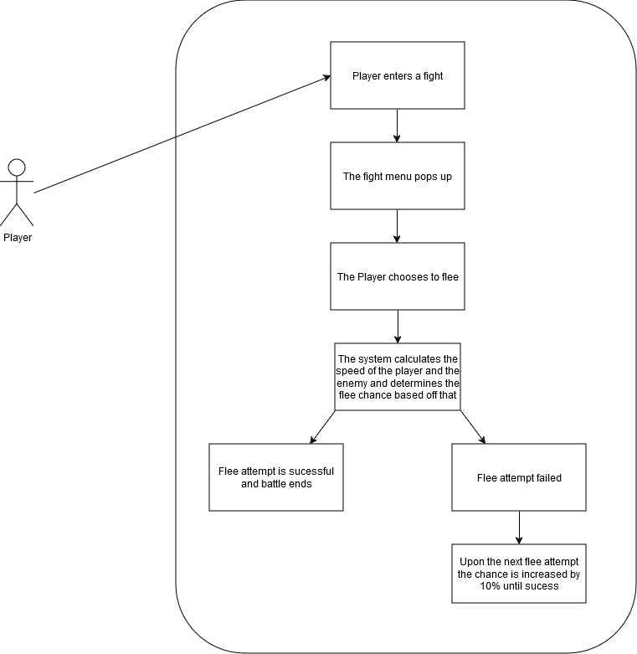

**Flow Description**

**Precondition**

The player must have entered a battle with an enemy

**Activation**

The player must currently be in a battle with an enemy.

**Main flow**

1. The Player chooses the option to flee.
2. The system checks the speed of the Player and the Enemy
3. The system calculates the chance of a successful flee attempt
4. The system displays that the flee attempt was successful

**Alternate flow**

1. The Player chooses the option to flee.
2. The system checks the speed of the Player and the Enemy
3. The system calculates the chance of a successful flee attempt
4. The system displays the flee attempt was a failure
5. The system adds an extra 10% chance to the next flee attempt when the player tries again
6. The system ends the player’s turn, and it becomes the enemy’s turn

**Exceptional flow**

1. The game crashes
2. The game reopens at home page.
3. The game autosaves.

**Termination**

The system ends the battle by either the player escaping the battle or if they die in battle

**Post condition**

The system goes into a wait state until the player gets into another battle

**List further functional requirements here, using the same structure as for Requirement1.**

## Requirement 8 Battle: Enemy Attacking

This shows off the attack command within battle for the enemies

## Priority

If the enemies do not attack, then the player wouldn’t have any level of challenge when it comes to battles and enemies would be nothing more that HP sponges that just waste the players time

**Name**

Enemy attack use case

**Number**

Use case 008

**Scope**

The scope of this use case is to show off the turn of an enemy

**Description**

This use case describes the how an enemy’s turn plays out

**Use Case Diagram**

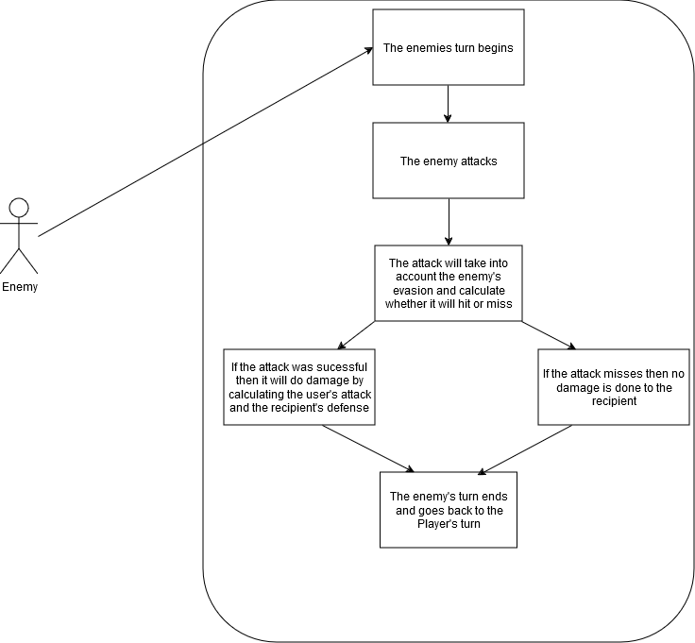

**Flow Description**

**Precondition**

The player must be in a battle with an enemy

**Activation**

This use case starts when the player has done an action and the system ends

**Main flow**

1. It becomes the enemy’s turn
2. The enemy’s attack either hits or misses
3. The system calculates the user's accuracy and the recipient’s evasion
4. The attack hits and the player takes damage from the enemy
5. The system ends the enemy’s turn and starts the player’s turn

**Alternate flow**

1. If the attack misses, then the recipient takes no damage

2. The system ends the enemy’s turn and starts the player’s turn

**Exceptional flow**

1. The system crashes
2. The game reopens at home page.
3. The game autosaves.

**Termination**

The system ends the process if either the enemy or player dies in battle

**Post condition**

The system goes into a wait state until the player gets into another battle

## Data Requirements

Requirement 1: Data for items (Number of items (Integer), Effects of items (Integer, string, Boolean), Description (String))

Requirement 2: Data for enemies (Stats, Attack, Defense, Magic attack and Defense, Speed, Evasion (String, Integer)

Requirement 3: Data for Player (Stats, Attack, Defense, Magic attack and Defense, Speed, Evasion (String, Integer)

## User Requirements

Requirement 1: The user can interact with objects

Requirement 2: The user can walk around

Requirement 3: The user can enter the mines

Requirement 4: The user can battle enemies

Requirement 5: The user can exit the mines

Requirement 6: The user can use items

Requirement 7: The user can use the menu to save, check items etc

## Environmental Requirements

The users must have a capable enough PC to be able to handle any demands the game may throw at the system.

## Usability Requirements

## Design & Architecture

Within RPGmaker MV the cog icon at the top which I marked in the picture, The database is a pop-up window where I can access next to everything I need for creating all the backend components like events, enemies, Items, Skills etc.

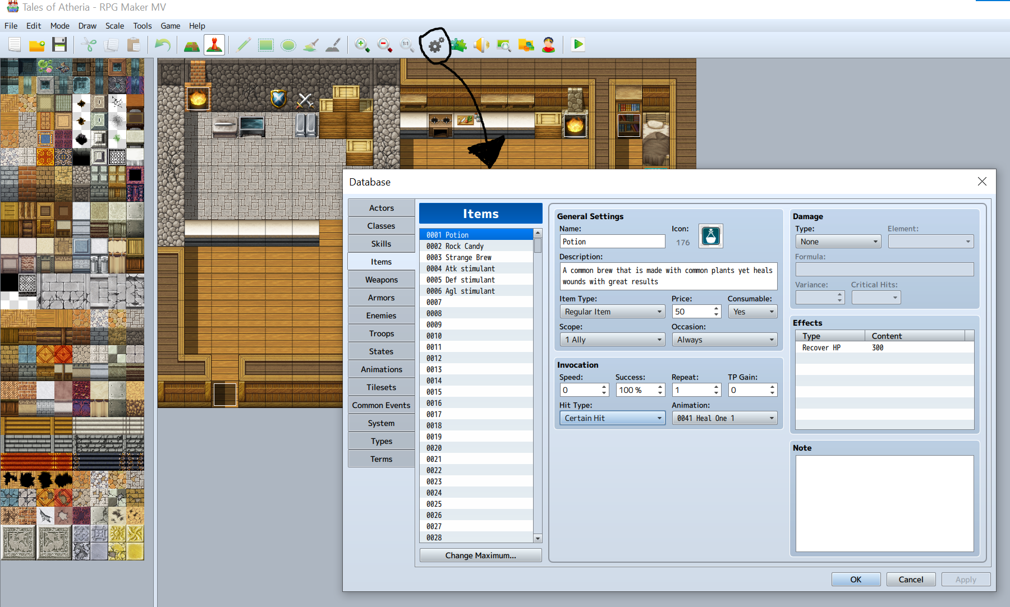

I’m going to break down some of the various items and enemies would come across in the game, my database within RPGmaker MV contains all the things I have created so let's begin with the Potion

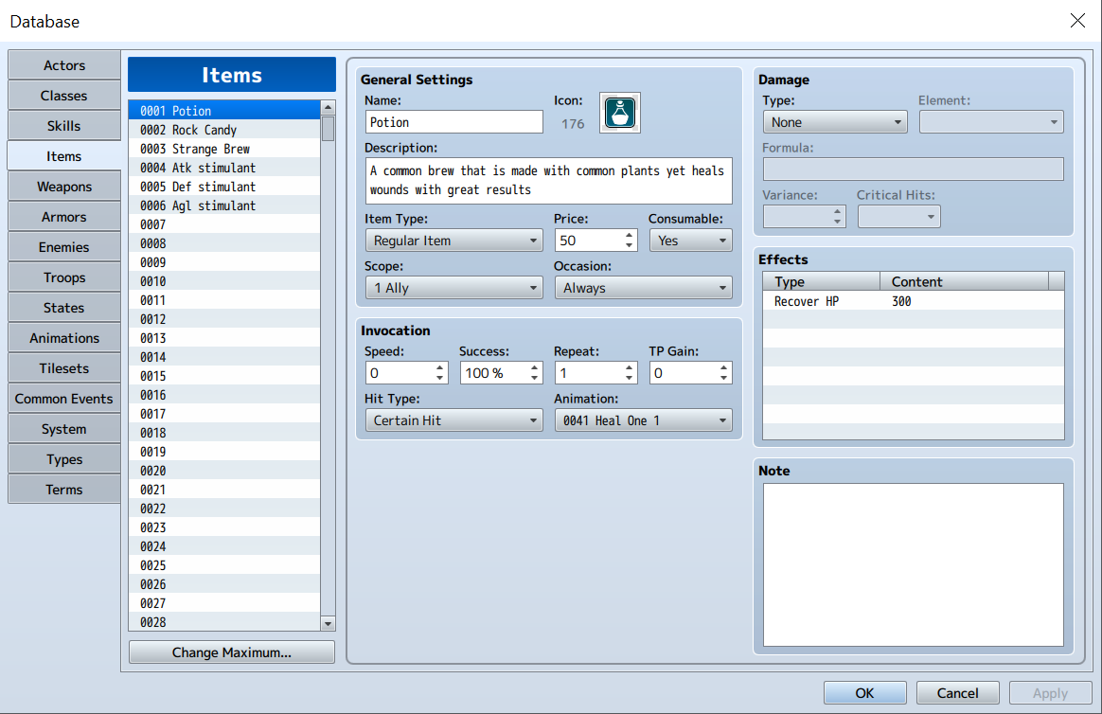Here in my database, we can see in the Items tab the first item is a simple potion. We can see all the information on the potion from its name to deeper information like how it works when its used. So let’s break down how this item works, Starting with the scope. The scope of items can range from singular allies to enemies to dead party members. As we only have one party member there isn’t any reason to make items target multiple members.

Occasion means when the player can use it, Since it’s set to always this means that the player can use it both in and out of battles

The two most important parts of the item are the Invocation (Which is the parameters when using it) and the Effect (Which is what happens when you use it). It is set at “Certain Hit” as if it was set to say “Magical attack” then it has a chance to fail which doesn’t really make sense for a potion does it. “Certain Hit” is programmed to always take effect even if the player’s accuracy was affected by something, The “Repeat” parameter means how many times the effect will happen and so since it’s set to 1 then the effect of 300 HP recovery happens once.

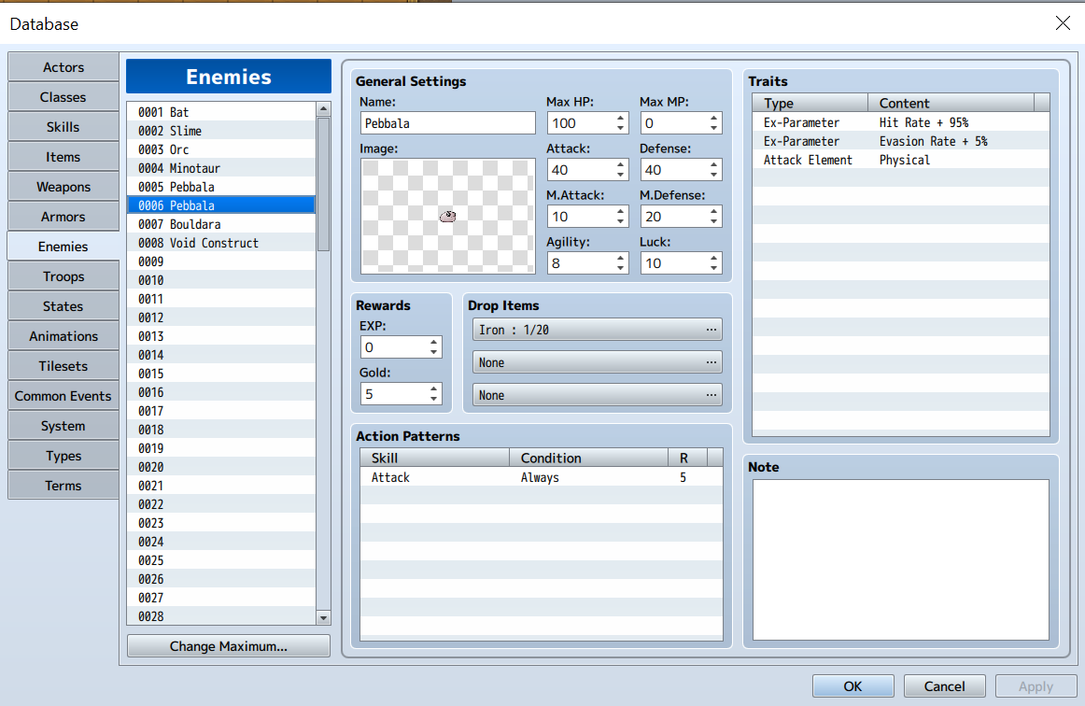

The next thing I wanted to show was an enemy I created named Pebbala, They’re the staple enemy of the first area and this is the screen where I can edit its stats, how it looks with the image, It’s attacks, traits and its rewards for defeating it.

Namely I want to go over its Actions and Traits. To explain its actions, it very simply has one move and that's to attack the player and if you were to look at its attack element in the traits then you would see that the hit is physical. For now it doesn’t matter all that much but with more refined RPGmaker games you can have characters or enemies take less or more damage to certain elements such as a plant that takes more damage to fire. Its other traits it’s accuracy and its evasion, It may say +95% up there but that just means it has a 95% hit rate with attacks, so if the player gets lucky the might be able to avoid damage. The evasion is the same idea where it’s dodge chance is 5% so even if the attack hits it could also dodge the attack.

## Implementation

While I was thinking about that to show off for implementation I was thinking about some of the most important events for the game. So one of the most important ones is this Iron ore rock that I scripted for the game.

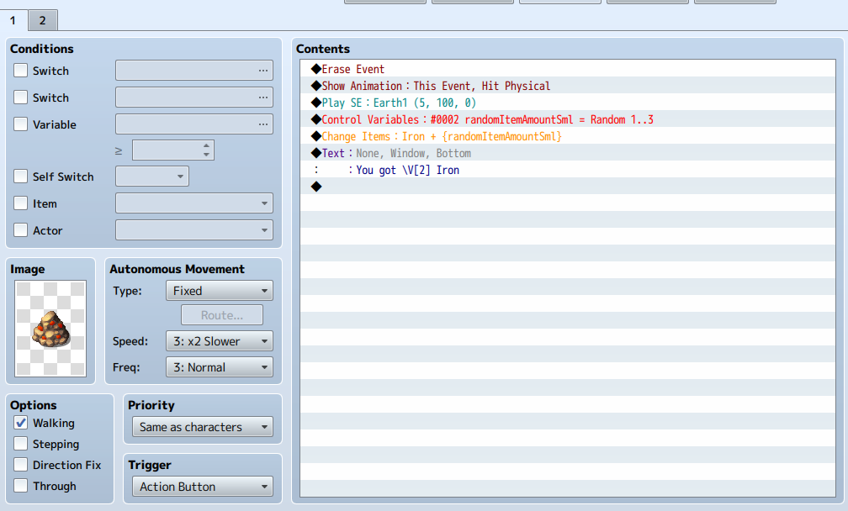I wanted to show off this rock that I scripted since they are littered within the mines so the player will be interacting with them a lot. If we look at the contents of the rock, we can see an erase event as the first thing that will happen if the player interacts with it. To signal to the player that they have broken the rock a visual effect of the rock breaking plays along with a crumbling sound effect. The most important part of the event is the Items the rock will give, If you look in the contents you can see the Control Variables piece, This runs a simple variable which picks a number between 1 – 3. When a number is selected the event runs a change item script to add Iron pieces equal to the number the Control variable selected. For example If the control variable chose 3 then the Change items script would then give the player 3 Iron pieces. Lastly we have a text box that refers to the Control variable, If you look closely at the \V[2], This means that it refers to Variable 2. \V refers to the Variables and [2] means the second Variable.

One of my other most important events that I created was the Treasure chests, I made two different ones, and we will go over each one here.

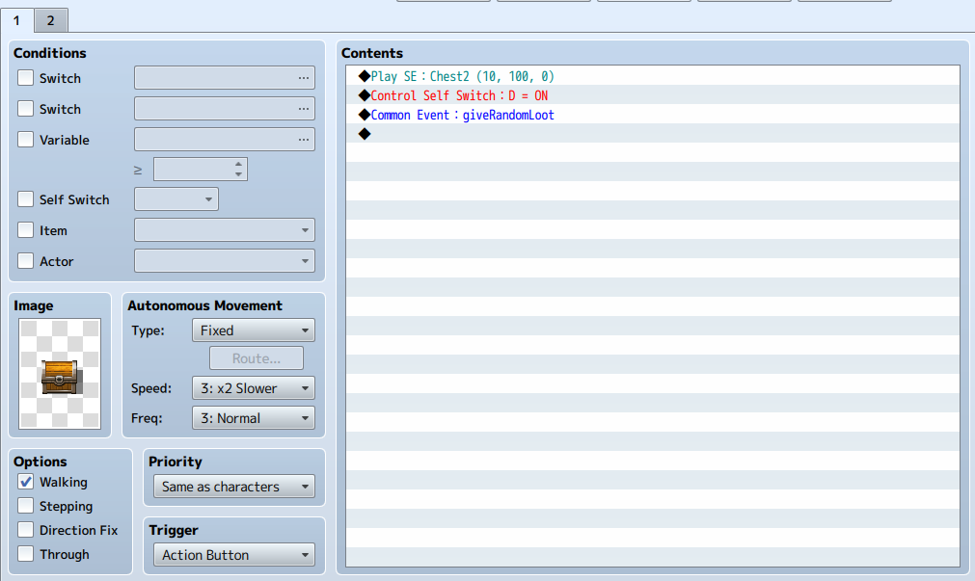Here we can see the simple chest and upon interacting it it will play a creaking sound to signal to the player its been opened. Now the most important part is that it controls its own self switch which means it basically turns itself off after the interaction. The next part is the one that gives the chest meaning, As you can see the common event runs an event called ”giveRandomLoot” which refers to a common event that I will show now.

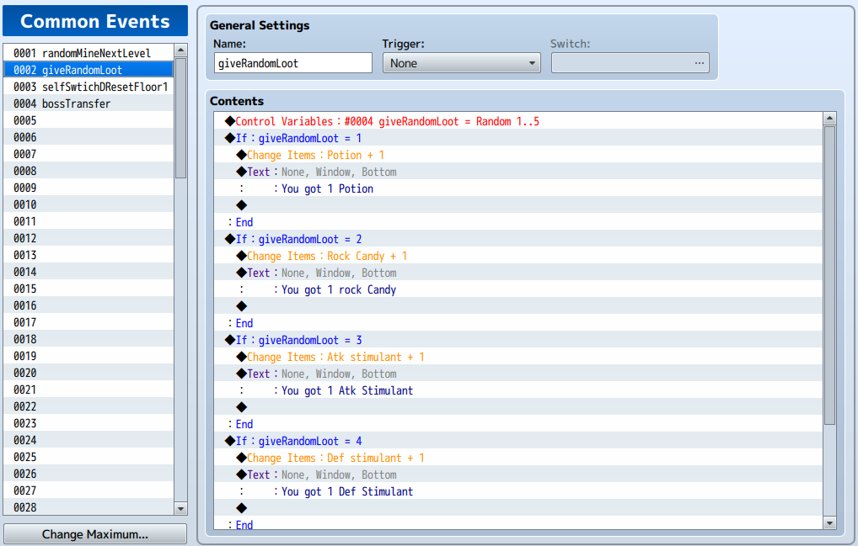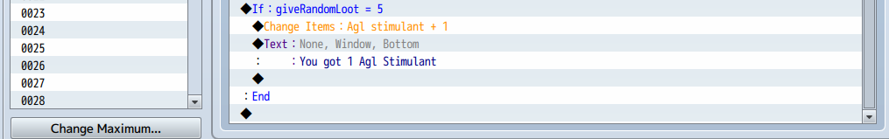I couldn’t fit all the text in one screenshot but this is the giveRandomLoot common event, The way it works is when the chest calls for the common event and this common event simply starts with a variable to pick a number between 1 – 5 and then gives an item corresponding to the number chosen by the variable.

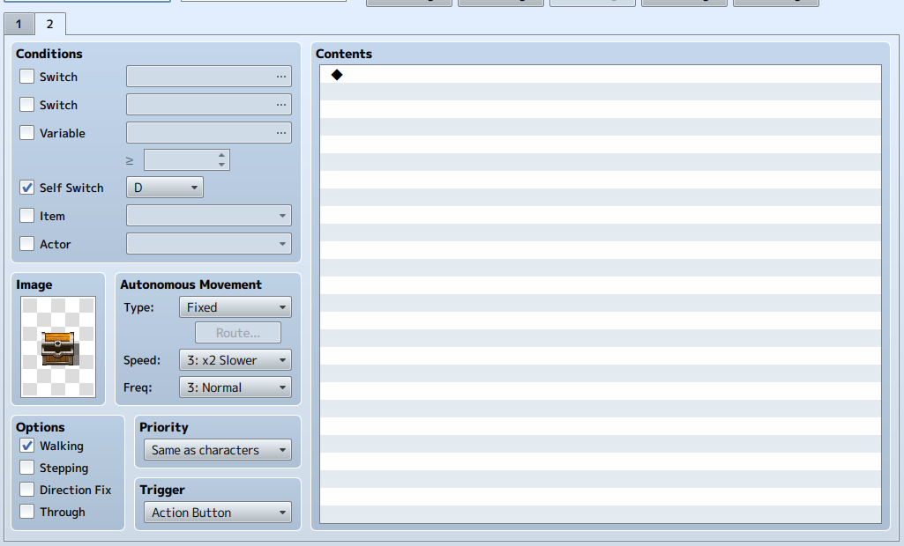

Here is what the chest looks like after its been used. You can see in the conditions the self switch is on and it is set to “D” and the image is an open chest which indicates to the player that it's been used.

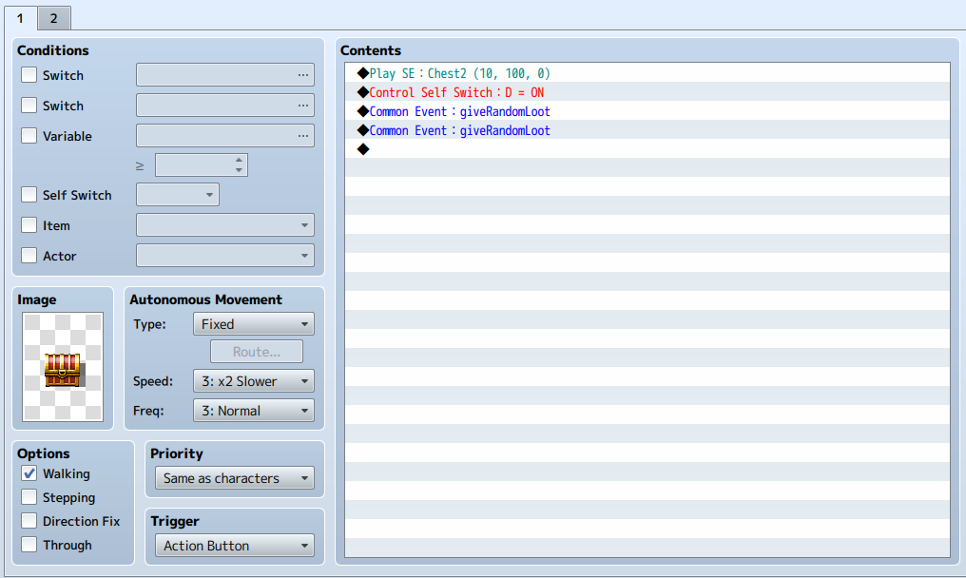Here is the special chest and while in game its much nicer to find in the scripting its only difference is that it gives two rolls of the random loot common event which just gives two items instead of one. Other than that its the same event.

## Graphical User Interface (GUI)

Main menu GUI

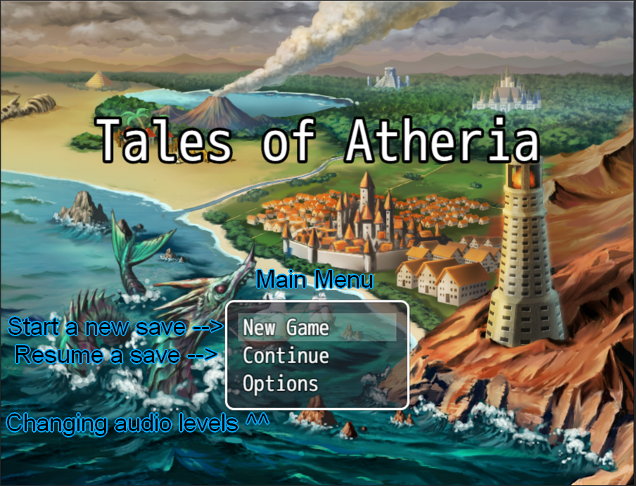

Main menu GUI

## 

This is the 1 of the 2 most important menu within the game, This menu in particular allows the player to Check their current items, Check their skills, Equip armour, Check their stats, They can edit the game volume, They can save the game here and lastly they can return to the title screen. Down in the bottom corner you can see the player’s current money however currently they have none.

Overworld Item menu

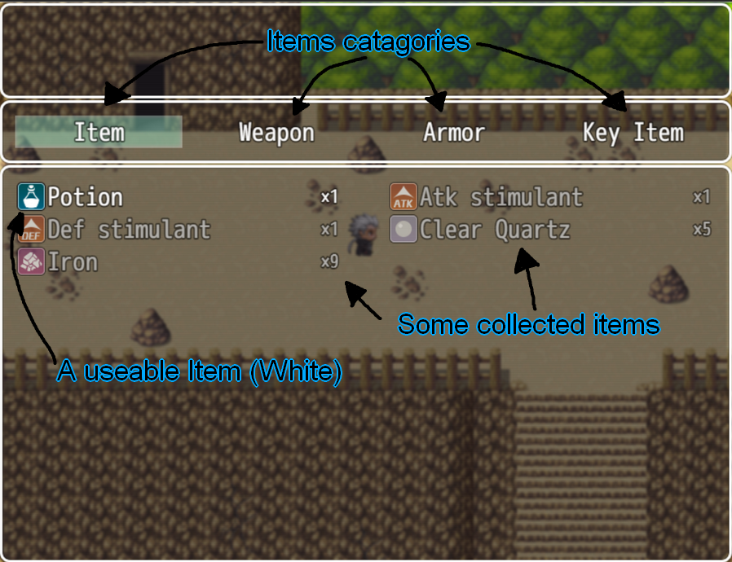

This is what happens when you open the Item section in the previous screenshot, You can see here there are four Item categories, “Item” which are classed as consumable within the database and can be used when they are in white text as you can see with the potion its in white text which means it can be used right now to restore HP. “Weapon” is the next category, This is where all your current weapons will be stored and you can see What's in that category by looking at it. “Armor” is the same as the “Weapon” category except for storing Armour pieces rather than weapons. Lastly, we have “Key Items” which are special items that would normally be stored for quests or other important things, I’ve yet to implement any but special story items would go into that category.

Starting Battle screen

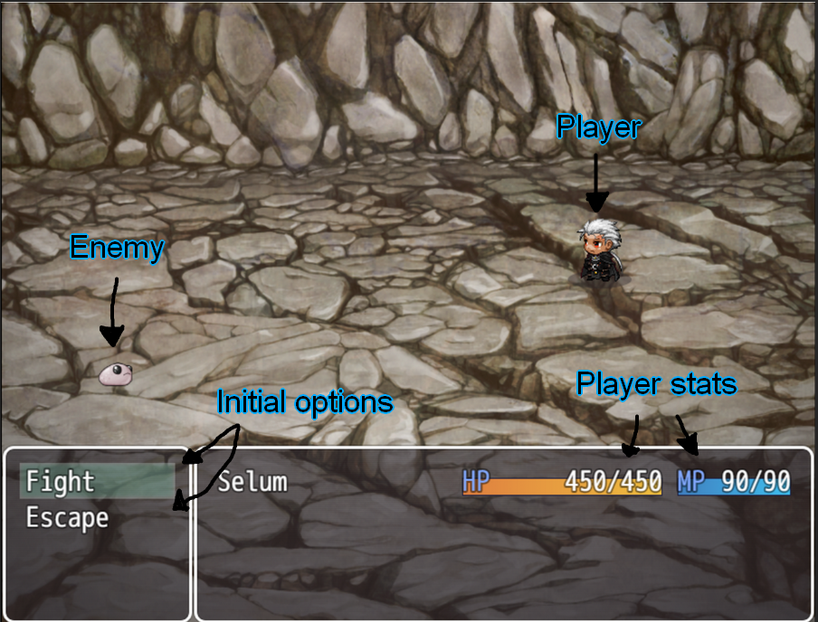

When you enter a battle, this screen is the first thing that appears. The player is immediately given two options to either Fight or try to Run away. If the player decides to run away the game will have the player character run away and if the escape was successful, then they get to flee and if it failed they lost their turn and the enemy gets to attack then the player may get another chance to either fight or run again. The other Option is fight which I will go into a little more detail in the next part

Battle Menu

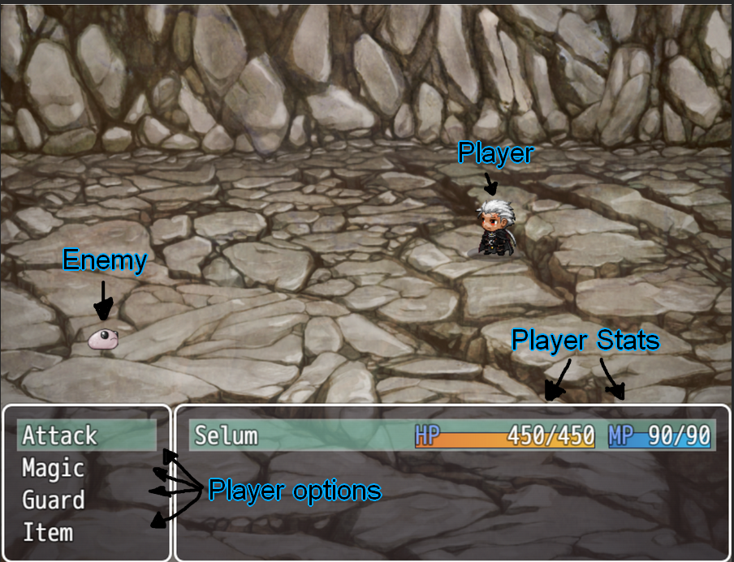

This is the main battle menu if the player choses to fight, You can do a basic Melee attack with Attack. Magic allows the player to use their skills which ill go over more in the next part. Guard increases your defence so you take less damage and Lastly, You can use items which you saw in a previous part the Items menu but Ill explain the difference between them in one of the next parts

Magic Menu

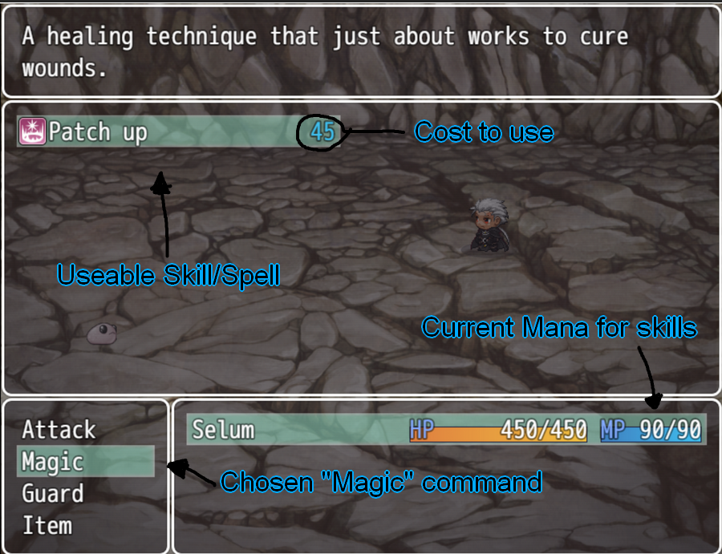

Going into the Magic menu you can see the Player has one skill “Patch up”, Since its white text that means they can use it right now. The blue number next to it is how much MP it costs and down where the HP and MP is the amount the have so they could use Patch up twice when they want to, I was considering adding extra skills but in the end I just stuck with this since i had no time for adding other abilities.

BattleItemMenu

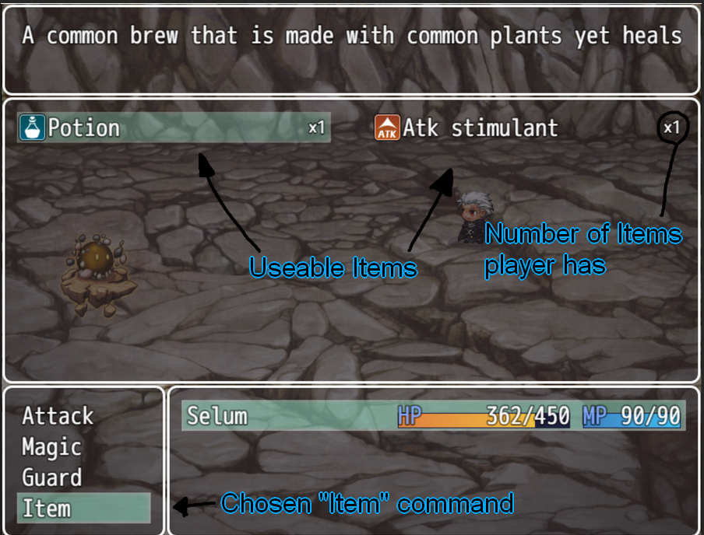

As you saw earlier the outside battle menu had a few items in it but when you are in battle it will only show items you can use, The Atk stimulant was unable to be used outside battle as I made to be a battle item only as what use would it have outside battle? You can also see there is an “x1” in each item, That is there to show how many of that item you have in your inventory so if you had 10 potions it would be “x10” and if you have 0 then it wouldn't be visible in your inventory.

## Testing

Through the time i have been working on this project I’ve been testing next to every event I’ve made which ranges anywhere from the Iron ore rock I talked about earlier all the way to simple interactions like moving through levels

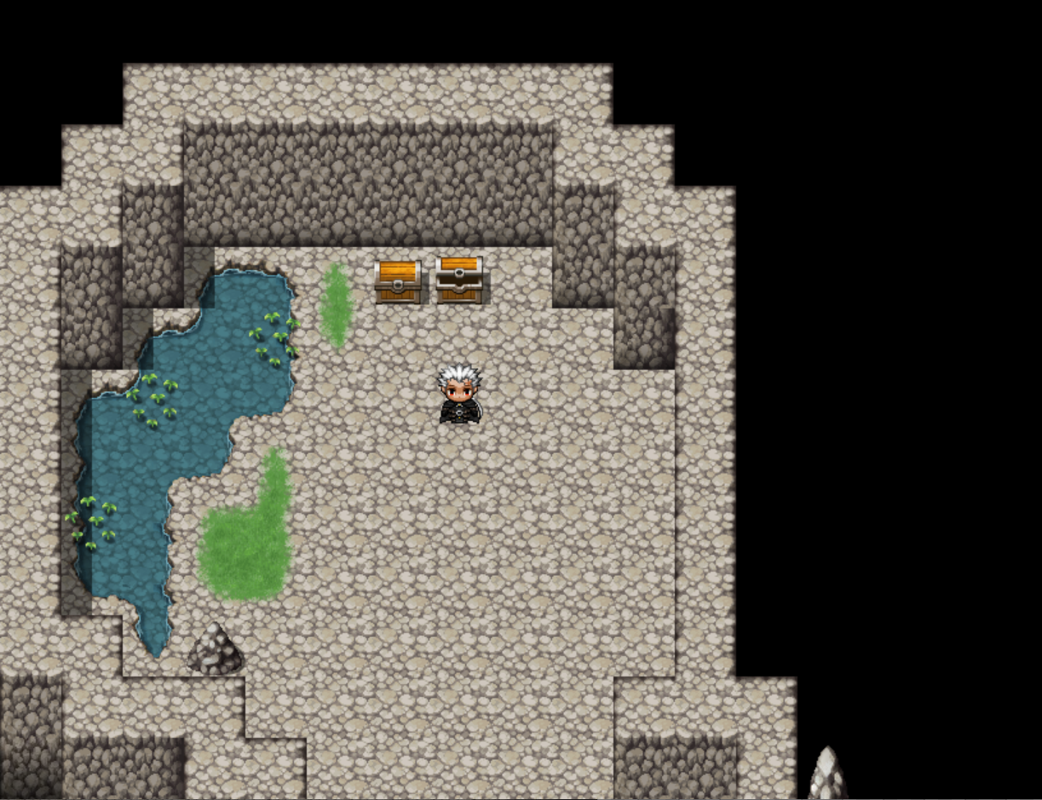Heres a little example of two loot chests where one Is opened already but the other is not opened yet.

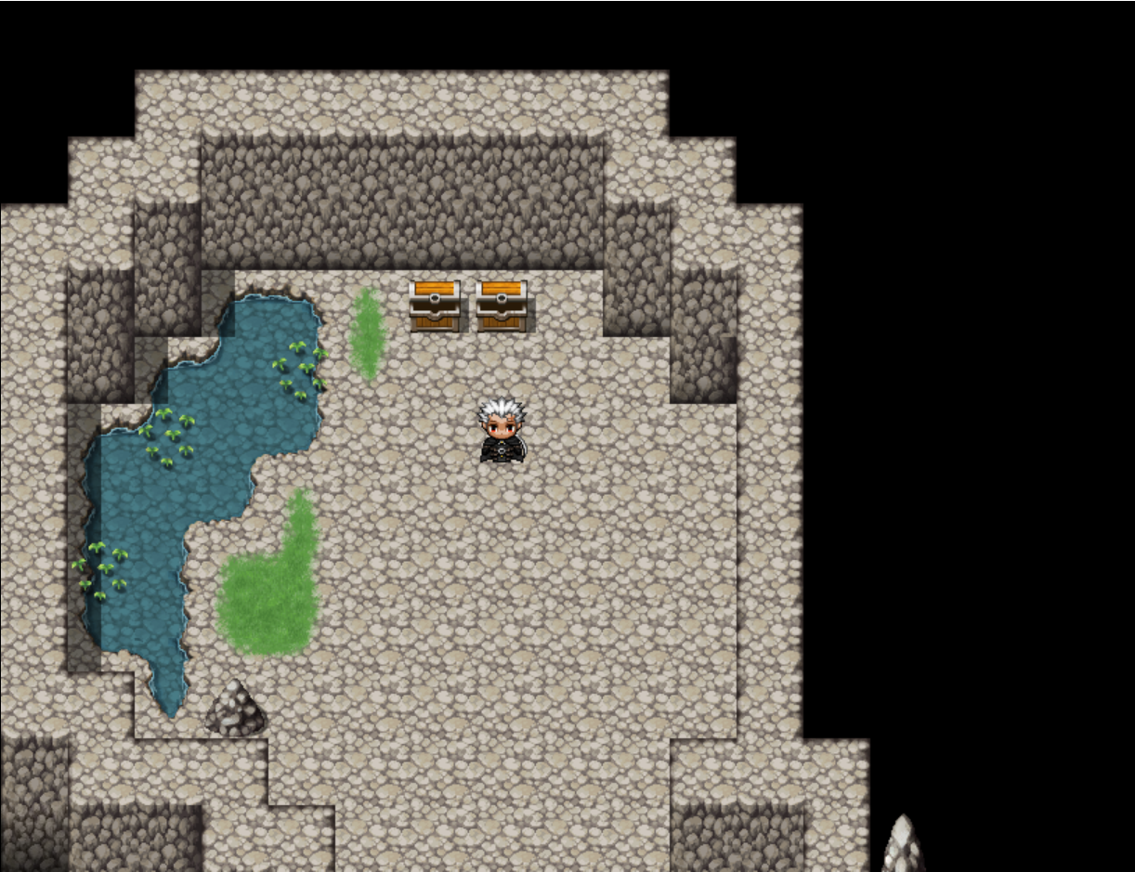Here is the other chest being opened now and I will also show you that the player would have gotten two items out of these two loot chests.

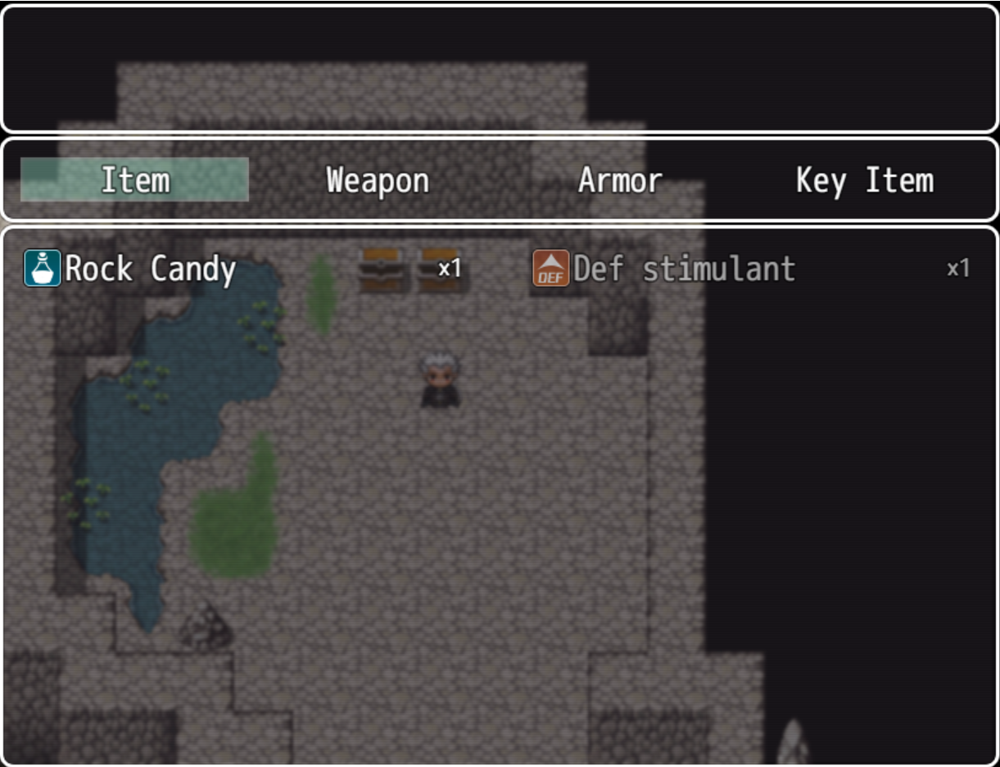Here we can see that the player received two items, A Rock Candy and A Def stimulant and you can also see the two opened chests in the background.

## Evaluation

During the basic testing I was running such as doing a test run of going through the mines I realised that the enemies are a little too strong to the point where the enemies just feel unfair and overpower you. It was especially bad when I initially tested as the basic enemies could 2-3 hit kill the player which would be very frustrating especially if you must fight multiple enemies at once. So, to balance the enemies I ran test battles to gauge how much damage each side took to find the perfect range. To also combat this, I made items to help the player more common such as potions to heal their Health and other items to boost their stats in battles which rather than making the player always stronger they can make strategic use of the items given to them.

# Conclusions

When I began this project all the way back in September, I initially wanted the scope to be much larger than what it currently is since I was extremely excited to finally be able to make a game as a project but as the months went by it got harder and harder to find time to work on the project and thus I had to be more realistic with how much i can put into this project such as one issue I had that was bugging me in early development which made me think a lot about how i should spend my time in terms of adding features

The issue i was talking about is my Iron ore, I created a rock that when you destroy it gives 1-3 iron ore which isn't the hard part. The part that made it difficult was figuring out how to respawn these rocks after they were destroyed. Initially I made a switch that would turn on when the player interacted with the rock which made it disappear but then I realised they wouldn't come back afterward even if the area was reset. So after a very long time of research and throwing solutions at the wall I found that erasing the event upon interaction would still give the items but also respawn the event if the player left the area and came back.

Even though I didn’t get as much done as I initially would have liked to have done I am still quite happy how much I was able to implement and can comfortably say that what I have is an acceptable amount. These 9 months have been quite the bumpy ride and has made me realise a lot about how I work and what I need to do to improve my work ethic and dealing with stress, it’s skills I can say that I will carry with me into the future and hopefully will help me.

# Further Development or Research

With how I left the game there is definitely room for the project to further blossom and grow to be a full fledged game. With what I have now is only what I could implement with the time constraints presented and while I could say that I’m finished with the project and just leave it to die I’d much rather continue development with this game as it’s quite a personal piece of work from my heart.

Some ideas I have floating around in my head would be to add possibly a party system where we can get NPCs to join us down on the expeditions down in the mines. A more concrete idea is adding more areas after the initial mines, Such as an Overgrown/Flooded/Lava cave with new enemies, Ores, Items and maybe new Hazards such as floor tiles that harm the player if they step on them or traps that do effects.

The most important part of this that I had in mind was that I intended to work with RPG maker to create games even in the future and so this was a big step with problem solving and learning techniques with RPG maker.

# References

Please include references throughout your document where appropriate. See [here](https://libguides.ncirl.ie/referencingandavoidingplagiarism) for a guide on referencing from the NCI library.

RPG Maker Forums. (2018). *Controlling self switches from common events*. [online] Available at: <https://forums.rpgmakerweb.com/index.php?threads/controlling-self-switches-from-common-events.99157/> [Accessed 11 May 2025].

‌YouTube. (2014). RPG Maker MV Random Repeatable Dungeons Tutorial <https://youtu.be/O7MGrPrfHGE?si=MWhdyqmRsCiEB86c> [Accessed 11 May 2025].

# Appendices

## Project Proposal

# Objectives

For my project I set out to make a rougelite game with a little bit of permanent progression. I want it to be simple to understand so most can play it but somewhat difficult to get good at so the player feels rewarded for doing well.

# Background

The game will outline the basics of itself simply and concisely but it will challenge you on how to well execute these concepts in practice, Like for example fighting will be rather tough at the beginning but a smart player could beat enemies before they are properly equipped to do so. I intend to have an NPC in the town to remind the player about mechanics if they forget anything.

# State of the Art

I’ve only ever come across one game that does a similar thing to what I vision and that is an Indie game called Moonlighter. That game has you kill enemies for resources like slime etc, I intend to have you avoid enemies in the beginning, which is quite unlike standard Rougelites, Instead mining for resources like Iron, Gold etc but enemies will drop special resources that would be useful in later game.

# Technical Approach

The plan for development is a 3-phase plan. Part 1: Building, For the beginning of this project I want to make a rough idea for how I want the game to look and maybe a small story, With this I also want to develop the Main character (MC) so players might appreciate them.

Part 2: Development, This phase will take the longest (Most likely) Since ill be making everything for the game here, Levels, Characters, Animations, Mechanics etc. I also will need to build a complex system to randomise level layouts since that is the point of a Rougelite, That will by far take the most time out of all the things I need to develop.

Part 3: Bug squashing/testing: Rather self-explanatory, This phase will be mostly testing all the things I’ve made, I will be writing all these things down and ordering them by how severe the bugs are and therefore the most severe will be fixed first and then continue down the list, I may even have to change certain things within the game depending on certain factors.

# Technical Details

The software I want to use is called RPGMaker MV, It’s more of a visual coding language that primarily uses Javascript for its code language. However It’s still just a complex as other software like Unity or Godot but takes it in a more visual route which is better for me to use since I can learn and work better like that.

# Special Resources Required

The only possible resource I might need Is my steam deck if I wanted to make it playable on the Steam deck, I do own one but I’m not sure if I will make it playable on the Steam deck however I will add it here just in case I do end up doing that.

# Project Plan

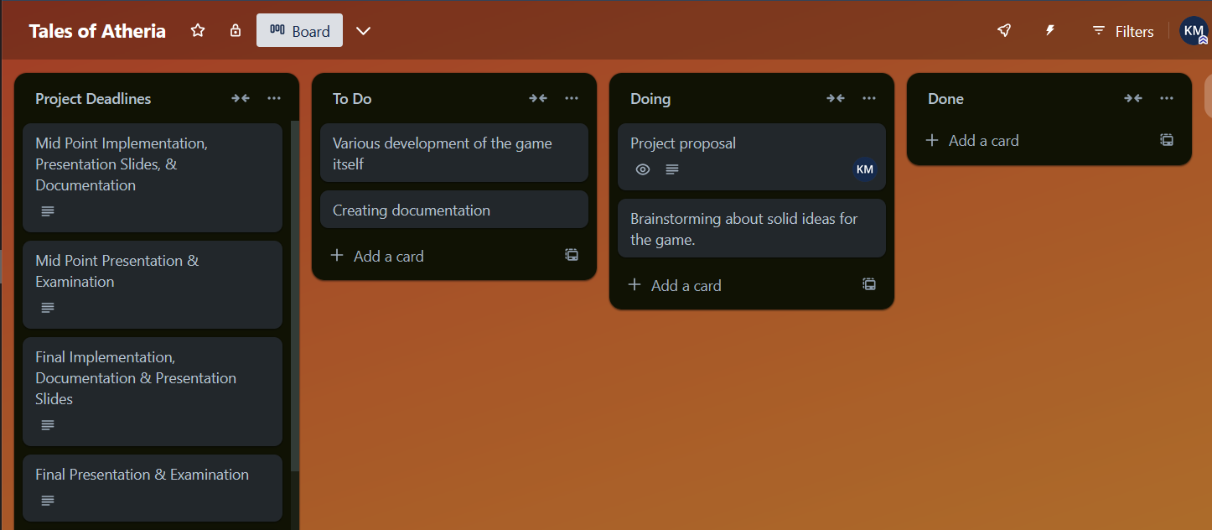

This is a rough idea of the current things I need to do for the project, I talked with my supervisor about where I currently am for the project, they told me to work on my idea as I have a good base but it needs more of a concrete idea so it can be implemented well enough to be compelling for the player, I intend to begin development for the game starting next week.

# Testing

I Intend to be doing unit tests after every chunk of Development has been done, With RPGmaker MV it is a bit easier to do testing like that since it has a feature where you can test specific parts of code by themselves If the work. Along with that I Intend to do Playtesting after each chunk of development has been completed making sure no bugs appear through play.

## Reflective Journals

September

|  |  |
| --- | --- |
| **Student Name** | Karl Miller |
| **Student Number** | 21522489 |
| **Course** | BSH in computing |
| **Supervisor** | Emer Thornbury |

|  |  |
| --- | --- |
| **What**?  Reflect on what has happened in your project this month?  We were tasked with coming up our ideas for our 4th year project and challenged on if our idea is actually possible. | |
| **So What?**  Consider what that meant for your project progress. What were your successes? What challenges still remain?  Now we need to fine tune the idea for our project idea and think about what is important and what we need to do. | |
| **Now What?**  What can you do to address outstanding challenges?  I’m going to ask about some of these problem and where to go from here with what I need to do. | |
| **Student Signature** | Karl Miller |

October

|  |  |
| --- | --- |
| **Student Name** | Karl Miller |
| **Student Number** | x21522489 |
| **Course** | BSHCSD4 |
| **Supervisor** | Emer Thornbury |

|  |  |
| --- | --- |
| **What**?  Reflect on what has happened in your project this month?  This month I got my supervisor which was Emer as stated above, We were able to have one meeting due to a few complications with outside factors however during my first meeting we discussed the idea of my project and how I can improve and flesh it out to which I have and I shall talk to my supervisor tomorrow about what to do next. Ive been able to get the groundwork for my idea created and I'll begin development with some level concepts etc. | |
| **So What?**  Consider what that meant for your project progress. What were your successes? What challenges still remain?  I've started to get the ball rolling in terms of gameplay design and some story so thats always a big step in development with the project however I still am yet to get started on actual development for the prokect and I would like to get to work soon, There will be a lot of things I need to make for this project but I'm really excited to get to work on something I'm super passionate about. However something Emer mentioned to me was to not lose focus of the project and be more critical of my ideas so my work isnt sloppy | |
| **Now What?**  What can you do to address outstanding challenges?  The only thing I can really say is that I need to put plenty of time into development and research what's most important in terms of what I need to work on and talk to my supervisor about the next steps in development. When it comes to my ideas I'll need to sit down and think about them more critically wether they are actually good or not | |
| **Student Signature** | Karl Miller |

November

**Supervision & Reflection Template**

|  |  |
| --- | --- |
| **Student Name** | Karl Miller |
| **Student Number** | X21522489 |
| **Course** | Bachelor of Science (Honours) in Computing, Year: 4 |
| **Supervisor** | Emer Thornbury |

|  |  |
| --- | --- |
| **What**?  Reflect on what has happened in your project this month?  This month was all about setting up my documents for my pre-development stage, Such as Flowcharts, Use cases, A Gantt chart etc. With a fair amount of assistance from my supervisor I was able to create more accurate and professional looking documents which will push me in the right direction when it comes to developing the game itself. | |
| **So What?**  Consider what that meant for your project progress. What were your successes? What challenges still remain?  I feel more confidant in my processes for developing the game when it comes to the beginning of development, The use cases I’ve created give me a foothold when it comes to starting my developing and making sure the absolute basics are fully functioning and creating a very basic build of the game. I still need to create the presentation for the Midpoint presentation. | |
| **Now What?**  What can you do to address outstanding challenges?  The simple answer to all these outstanding issues is I need to blast through all these documents and build a basic build for the Midpoint Presentation, It’s a big hurdle but If hard work is put into it i should have not too many issues now. | |
| **Student Signature** | Karl Miller |

December

**Supervision & Reflection Template**

|  |  |
| --- | --- |
| **Student Name** | Karl Miller |
| **Student Number** | x21522489 |
| **Course** | BSHCSD4 |
| **Supervisor** | Emer Thornbury |

|  |  |
| --- | --- |
| **What**?  Reflect on what has happened in your project this month?  Within this past Month we have done our Mid-Point presentation and have created a prototype of our games to show off for said presentation, I admittedly was a little messy with my presentation however i believe what I showed off was quite good for a prototype, If I could do it again I definitely would practice the slides more but as for my Prototype it gave me more to think about when it comes to adding more to my project as I was asked some interesting and thought provoking questions | |
| **So What?**  Consider what that meant for your project progress. What were your successes? What challenges still remain?  I was rather proud of myself for creating my prototype as it gives me confidence for making a more fleshed out version of the game. While all this is good, I still have a long way to go as I want to add lots more features and a story so the player can get more immersed, with all these other features means lots of learning and practice is involved however I’m up to the task. | |
| **Now What?**  What can you do to address outstanding challenges?  When it comes to current challenges, I need to revise my plans for development and come up with an effective work ethic. I also need to do more research for working with RPGMaker and learn to make custom scripts for developing unique parts for my game. | |
| **Student Signature** | Karl Miller |

January

**Supervision & Reflection Template**

|  |  |
| --- | --- |
| **Student Name** | Karl Miller |
| **Student Number** | x21522489 |
| **Course** | BSHCSD4 |
| **Supervisor** | Emer Thornbury |

|  |  |
| --- | --- |
| **What**?  Reflect on what has happened in your project this month?  Classes have started back up for the second semester and I haven’t fully started working again however I have come to a few conclusions on things I need to work on, Like fitting in the story I want to add to the game, adding more game mechanics and making it seem more “Full” | |
| **So What?**  Consider what that meant for your project progress. What were your successes? What challenges still remain?  Well from what my teacher told me I did quite well when it came to the mid point presentation so that was a nice boost in confidence as I know now what I'm doing is a step in the right direction at least, While that is a nice bit of knowledge I still need to do the bulk of the work in the coming months with this in mind I need to have my first meeting with my supervisor about what's next after the mid point. | |
| **Now What?**  What can you do to address outstanding challenges?  I intend to sit down some more and consider how to tackle the problems I now face with the continued development but for now I’d rather wait to talk with my supervisor so I can bounce ideas off her and so she can give me guidance on what I need to do next with my project. I might chip away some more at it but ill definitely have more stuff to write next month when it comes to having new things added | |
| **Student Signature** | Karl Miller |

February

**Supervision & Reflection Template**

|  |  |
| --- | --- |
| **Student Name** | Karl Miller |
| **Student Number** | x21522489 |
| **Course** | BSHCSD4 |
| **Supervisor** | Emer Thornbury |

|  |  |
| --- | --- |
| **What**?  Reflect on what has happened in your project this month?  This month has been tough when it came to my project but it wasn’t directly tied to it, While yes I have a lot to work on generally when it comes to the project and Also fixing up some things from the Mid-point presentation Like working on my diagrams as some weren’t as good as they could have been and other smaller general updates but also outside factors like other college assignments | |
| **So What?**  Consider what that meant for your project progress. What were your successes? What challenges still remain?  There’s a few things I can take away from this month, I have to prioritize better and That I know I can put in more effort. I have a good idea of what I want to do but I need to use my time better, With that knowledge I know I can get what I want to do done | |
| **Now What?**  What can you do to address outstanding challenges?  I need to Improve my prioritization but I can work on the things much more as soon as my other CAs are finished which they will be finished soon enough | |
| **Student Signature** | Karl Miller |

March

**Supervision & Reflection Template**

|  |  |
| --- | --- |
| **Student Name** | Karl Miller |
| **Student Number** | x21522489 |
| **Course** | BSHCSD4 |
| **Supervisor** | Emer Thornbury |

|  |  |
| --- | --- |
| **What**?  Reflect on what has happened in your project this month?  This month was by far the hardest month so far but also the month I might have gotten the most work done, Admittedly I was struggling on some stuff that was boiling for a while now and during this month I broke down so there's a good lesson to learn here with stress management and how i need to work on that. As for work with the project itself I created a bundle of new floors for level variety up to the boss floor but the boss needs to still be implemented | |
| **So What?**  Consider what that meant for your project progress. What were your successes? What challenges still remain?  I still want to add an entire new area and after my other assignments for college are finished then I can get to work on adding those and a few NPC's that the player can interact with. I still have my work cut out for me but they are giving us a month so solely work on the project so if all goes well, I should be just fine with what I want to do | |
| **Now What?**  What can you do to address outstanding challenges?  To handle the current challenges I'll need a clear head so until the other assignments are out of the way I will plan things out but not make any additions until after my other things are done, that way I won't get overwhelmed and panic if i try to add to many things to my project! | |
| **Student Signature** | Karl Miller |

May

**Supervision & Reflection Template**

|  |  |
| --- | --- |
| **Student Name** | Karl Miller |
| **Student Number** | x21522489 |
| **Course** | BSHCSD4 |
| **Supervisor** | Emer Thornbury |

**Month:**

|  |  |
| --- | --- |
| **What**?  Reflect on what has happened in your project this month?  I’m starting to feel the pinch now with these last two weeks of work I've been doing for this project however now we coming to a head with the project as we have to submit it now. Thankfully with my careful planning with what I felt like i could get done in the time I have left I am satisfied with where I’m at with what I’ve developed | |
| **So What?**  Consider what that meant for your project progress. What were your successes? What challenges still remain?  I’ve gotten the game to a “Complete version” as I've called it. What I mean by this is that it is at a point where I could consider it complete to my standards for the submission however, I’ve left it very open for further development If I wish to continue working on it. As for challenges, I’d say the biggest one now would be to handle the presentation, Other than that I’m not worried anymore | |
| **Now What?**  What can you do to address outstanding challenges?  The best thing I can do for dealing with my stage fright for the Presentation is to simply practice what I’m going to talk about and time it so I’ll be ready and go from there | |
| **Student Signature** | Karl Miller |

## Other materials used

Any other reference material used in the project for example evaluation surveys etc.